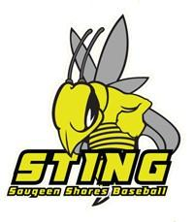
SAUGEEN SHORES MINOR BASEBALL
REP and SELECT TOURNAMENT REGISTRATION FORM
JUNE 19th-21st 2020

Association: ___________________________________________________________________________

Team name and OBA Number:_______________________________________________________________________

Level (circle one): ROOKIE MOSQUITO PEEWEE

OBA Classification (circle one): B C D Select

Head Coach’s Name: ___________________________________________________________________

E-mail Address: ________________________________________________________________________

Home Phone Number: _________________________ Cell Number: _____________________________

Head Coach’s Signature ______________________________________________________
Cheques for $400.00 registration to be sent to:
SSMBA c/o Jeff Myatt
998 Arlington Street
Port Elgin, ON
N0H 2C4

