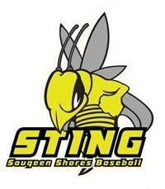
SAUGEEN SHORES MINOR BASEBALL
REP and SELECT TOURNAMENT REGISTRATION FORM
(B AND BELOW)
June 18 - 20 2021
$450 Entry Fee- Guaranteed 3 games

Association: ___________________________________________________________________________

Team name and OBA Number:______________________________________________________________

Level (circle one): ROOKIE MOSQUITO PEEWEE
OBA Classification (circle one): B C D Select

Head Coach’s Name: _________________________________________Cell Number__________________
E-mail Address: __________________________________________________________________________
Managers Name _________________________ Cell Number: ____________________________________
Email address: ______________________________________________________

Registration form and Post dated cheques (June 1st) can be sent to:
SSMBA c/o Lorraine Carroll
679 Davey Dr. Port Elgin, ON N0H 2C3
OR Email to lgleasoncarroll@gmail.com

